Arts Industry
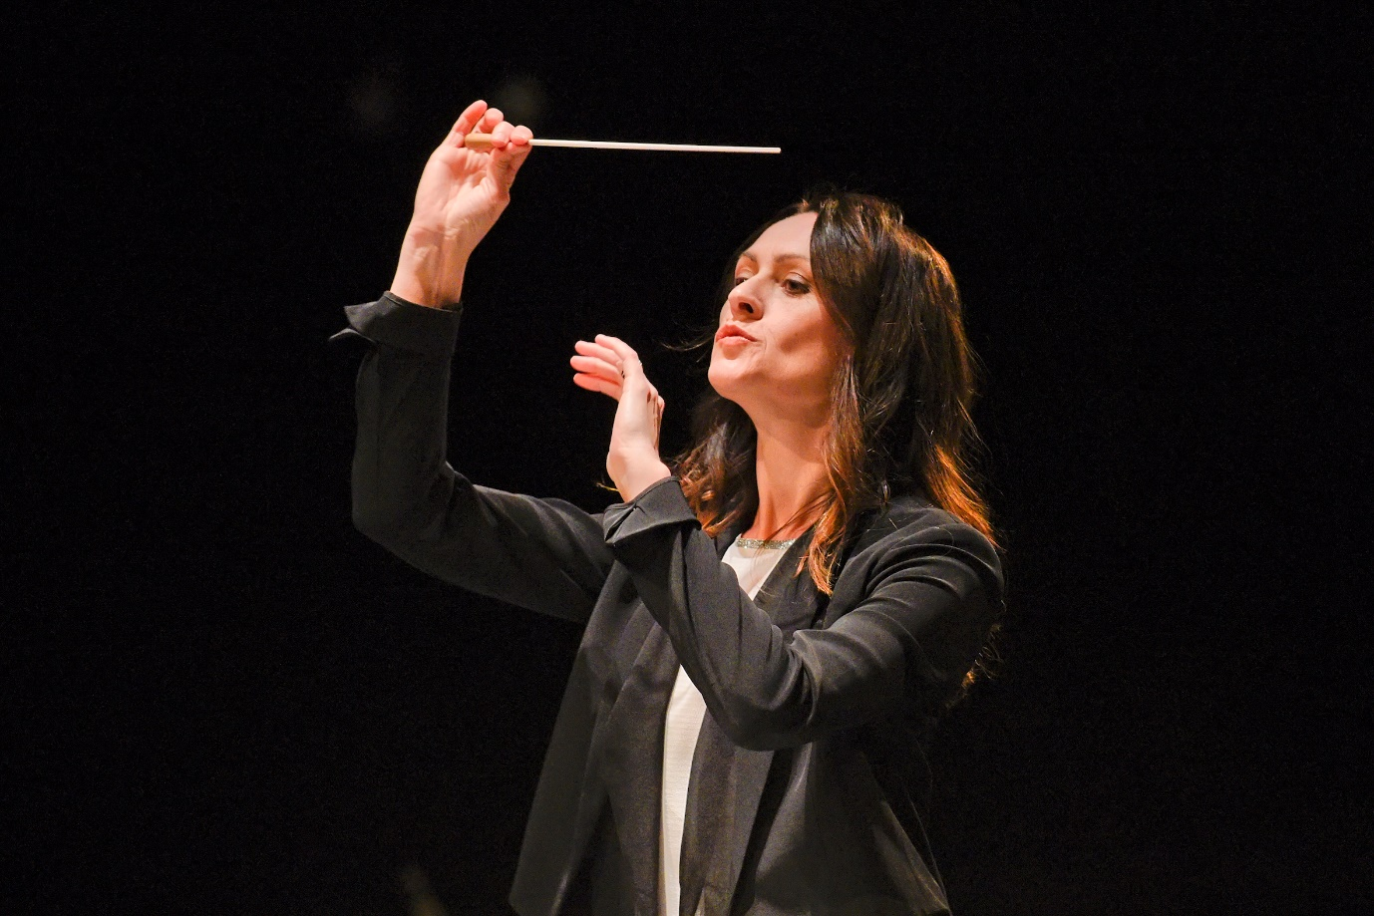

MY STORY Crowning glory
Written on 25 February 2019.
Natalie Murray Beale is the creative director of Independent Opera which has commissioned a new cantata, A Sheen of Dew on Flowers, about Queen Victoria and Prince Albert
This year sees the bicentenary of the births of both Queen Victoria and Prince Albert which will be marked by a new cantata by Joby Talbot. It has its premiere at the Barbican on April 11, the composition is one of a number of commemorative events including the exhibiting of the coronet at the V&A which Prince Albert gave to Queen Victoria, the story of which inspired the piece.
How did the commission come about?
The original idea was to create a musical work celebrating the gift of Queen Victoria’s coronet to the nation, and it came from Independent Opera’s co-founders, Bill and Judy Bollinger. Independent Opera (IO) was ready to commission a major new work. We have had smaller scale commissions arranged and performed at the Wigmore Hall and after promoting various UK premieres we felt this was our next step. Significantly, we were inspired by Queen Victoria and Prince Albert’s love and dedication to music throughout their lives.
Why was this particular subject chosen, and what is the story behind its title?
Joby and I started exploring the idea of this new work with a trip to the V&A to view Queen Victoria’s coronet. We were, very kindly, given a special preview by the V&A as the coronet will not be put on public display until April 11. We spent well over an hour with senior curator Richard Edgcumbe as he told us fascinating stories about the history of the coronet and the special significance it held for Queen Victoria and Prince Albert. He explained the craft behind this precious piece, the significance of the jewels, their shape and form, and the beautiful technology in the way the piece moves and changes, so it can be worn in many ways.
We were intrigued by the symbolism of the coronet, but more, we were interested in the people and the relationship surrounding the object. The idea of fidelity was very strong. The coronet was a marriage gift from Albert to Victoria, designed by him. It wasn’t stately, but delicate, to be worn by his beautiful bride. When Victoria emerged in public after mourning Albert’s death she wore the coronet, and carried her crown – a true expression of her devotion to Albert, and perhaps, a symbol of his still deep presence in her life, regardless of their physical separation.
A Sheen of Dew on Flowers could be a metaphor for the diamond light next to the sapphires on the coronet, but it is also a beautiful line from an Izumi Shikibu poem which Joby selected: Come quickly -- as soon as these blossoms open, they fall. This world exists as a sheen of dew on flowers.
A cantata is a piece of music for voices with instrumental accompaniment. How usual a form is this for such a commemoration, and did you consider others first?
Our first idea was for IO to commission an oratorio. I was curious as to what a modern oratorio could be, especially as it is such a valued musical form in this country, with regular performances by professional, semi-professional and amateur musical societies. Basically, we wanted this piece to be shared and it was also the thinking of Independent Opera’s founders, that it would be a gift to the nation. We want this great story to reach people, by listening, and we want people to have the opportunity to participate in future performances.
From this point, we changed our thinking slightly and moved towards the form of a cantata. Still with orchestra, choir and soloists, in common with an oratorio, but more intimate, 45 minutes in length, with a freer narrative.
Is there a narrative – and could there be an opera in the Victoria and Albert story?
I like your thinking! There is a certain timeless aspect to A Sheen of Dew on Flowers. Joby has set a collection of poetry from different centuries, millennia even. They are united by their descriptive qualities of love, partnership, passing, but they each offer a different angle on these themes. There is one clear overarching element however, the object of love recedes and diminishes over the course of the work.
It has been very interesting to watch new dramas, on TV or at the cinema, emerging about the life of Queen Victoria, so there is clear appeal and interest in her life’s story. I can certainly see rich material for an opera. Victoria and Albert shared a fascinating political, personal, exotic and adventurous life together alongside her extraordinarily prominent position in the world.
What is Independent Opera’s story?
IO was founded over ten years ago with the impetus to support young, serious artists in creating new works and productions. Our overall thinking is that artists grow by doing, by taking control and by taking risks. We staged a number of opera productions in the Lilian Baylis Theatre at Sadler’s Wells which focused on neglected repertoire, invested heavily in young artists and aimed for the highest of performance standards. Our directors worked with an unsympathetic opera space and their creativity drove this to be transformed from one production to the next. We have branched out from these productions now but have kept the same values: trust in young artists and passion for new works and creations.
You have been closely associated with opera most of your career, as both repetiteur and conductor. Does this piece signify a development in operatic composition?
The piece is written for a concert hall or similar space and isn’t conceived as a staged work. However, like the great oratorios of Handel, there can be true drama in this genre. What it has in common with the large majority of opera works is lyric material. Lines that sing. There is a rhythmic motor inside the music, often driven by piano and celeste and exotic sounds from gongs and percussion. Evocative – yes!
How did you select Joby Talbot?
We were exploring, several years back now, a new work by Joby which was a dance collaboration. Sadly, this didn’t progress as it became harder and harder to line up the schedules of everyone involved. Since then he has written a beautiful piece called Path of Miracles for choir, as well as a new opera, Everest, without forgetting his wonderful Alice for the Royal Opera House. So, when we were considering whom we should ask for this new commission, Joby was our obvious first choice.
The Britten Sinfonia will be the orchestra. Who will the singers be?
Kelley O’Connor is our wonderful mezzo soprano soloist. We’re delighted that she is joining us between engagements with the LA Phil. Her role in the piece is very much the protagonist and I know she will bring a mix of charisma, presence, heart and power to the music and poetry. She is joined by baritone Tobias Greenhalgh. Tobias has a beautiful, handsome voice and after many years singing in Germany struck us as the perfect partner, and figuratively they represent Queen Victoria and Prince Albert. In addition to the Britten Sinfonia orchestra, their affiliate choir, Britten Sinfonia Voices, will be performing.
You are also a guest professor at the Royal College of Music. Is there a new generation of opera composers coming through, or is it a dying art form?
Last year I had the pleasure of conducting a programme of new opera works by RCM composers. All of the RCM composition students were offered the opportunity to “pitch” their concept for an operatic work, sharing their motivations, excerpts of material, vision etc. I was struck by the enthusiasm in the room during these pitches and the hunger to get the gig - 25 composers pitched to us and 5 composers were chosen to write new opera and have their works fully staged. Judging by this experience I can absolutely vouch for this new generation of passionate opera composers.
The future of the art form itself is a different matter. We have the talent, it exists, and I believe that these talented artists will create their own version of what opera is today. It will be personal for them, they will write what moves them, it will reflect the world now. They also need support – stages, time, collaborators, finance to get started, people to take a chance on them, and, critical to everything, audiences.
How many performances of A Sheen of Dew on Flowers are scheduled?
At present, there is one performance scheduled at the Barbican Hall on the evening of April 11, although there is interest in future performances. The coronet will be unveiled at the V&A on April 11 – so you can make a full day of it!
Independent Opera’s creative director Natalie Murray Beale conducts the Britten Sinfonia in Joby Talbot’s new cantata A Sheen of Dew on Flowers at the Barbican on 11 April 2019 to mark the bicentenary of Queen Victoria & Prince Albert’s births.
https://www.barbican.org.uk/whats-on/2019/event/britten-sinfoniaindependent-opera

https://www.artsindustry.co.uk/feature/1533-my-story-crowning-glory

